# **Utilidades Bootstrap**

**Margin y padding**

Gracias a las nuevas Clases de Bootstrap 4 para **margin** y **padding** ahora podemos modificar facílmente la apariencia o posición de los elementos con solo llamar clases como **mt-3, pt-2, ml-5**, etc.

**Significados**

* m = margin
* p = padding
* t = top
* b = bottom
* l = left
* r = right
* x = left y right
* y = top y bottom

Puedes combinar o mezclar estas letras con los números del 0 al 5.

El margin o padding que crean estas clases son en “**rem**” y no en “**px**” (pixels) y los tamaños son los siguientes,

**Tamaños**

* 0 = 0 rem (para eliminar el margin o padding)
* 1 = .25 rem
* 2 = .5 rem
* 3 = 1 rem
* 4 = 1.5 rem
* 5 = 3 rem

Más información

<https://getbootstrap.com/docs/4.2/utilities/spacing/>

**Colores**

**Colores de texto**

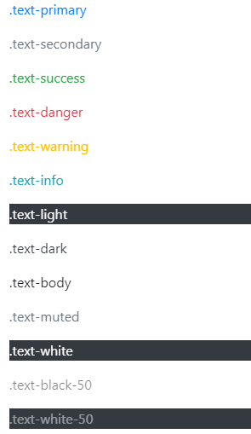

<p class="text-primary">.text-primary</p>

<p class="text-secondary">.text-secondary</p>

<p class="text-success">.text-success</p>

<p class="text-danger">.text-danger</p>

<p class="text-warning">.text-warning</p>

<p class="text-info">.text-info</p>

<p class="text-light bg-dark">.text-light</p>

<p class="text-dark">.text-dark</p>

<p class="text-body">.text-body</p>

<p class="text-muted">.text-muted</p>

<p class="text-white bg-dark">.text-white</p>

<p class="text-black-50">.text-black-50</p>

<p class="text-white-50 bg-dark">.text-white-50</p>

**Colores de vinculos**



<p><a href="#" class="text-primary">Primary link</a></p>

<p><a href="#" class="text-secondary">Secondary link</a></p>

<p><a href="#" class="text-success">Success link</a></p>

<p><a href="#" class="text-danger">Danger link</a></p>

<p><a href="#" class="text-warning">Warning link</a></p>

<p><a href="#" class="text-info">Info link</a></p>

<p><a href="#" class="text-light bg-dark">Light link</a></p>

<p><a href="#" class="text-dark">Dark link</a></p>

<p><a href="#" class="text-muted">Muted link</a></p>

<p><a href="#" class="text-white bg-dark">White link</a></p>

**Colores de fondo**

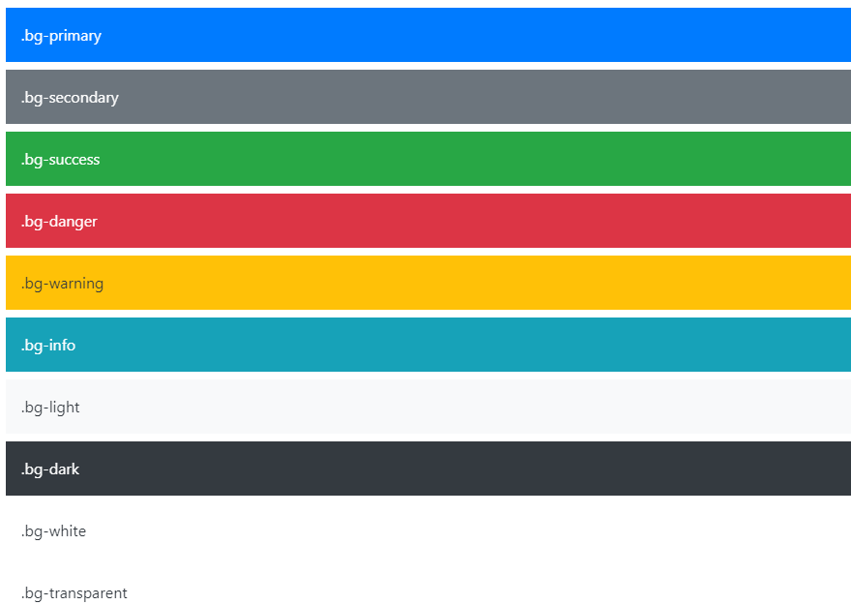

<div class="p-3 mb-2 bg-primary text-white">.bg-primary</div>

<div class="p-3 mb-2 bg-secondary text-white">.bg-secondary</div>

<div class="p-3 mb-2 bg-success text-white">.bg-success</div>

<div class="p-3 mb-2 bg-danger text-white">.bg-danger</div>

<div class="p-3 mb-2 bg-warning text-dark">.bg-warning</div>

<div class="p-3 mb-2 bg-info text-white">.bg-info</div>

<div class="p-3 mb-2 bg-light text-dark">.bg-light</div>

<div class="p-3 mb-2 bg-dark text-white">.bg-dark</div>

<div class="p-3 mb-2 bg-white text-dark">.bg-white</div>

<div class="p-3 mb-2 bg-transparent text-dark">.bg-transparent</div>

**Bordes**

**Aditivo**



<span class="border"></span>

<span class="border-top"></span>

<span class="border-right"></span>

<span class="border-bottom"></span>

<span class="border-left"></span>

**Sustractivo**



<span class="border-0"></span>

<span class="border-top-0"></span>

<span class="border-right-0"></span>

<span class="border-bottom-0"></span>

<span class="border-left-0"></span>

**Color del borde**



<span class="border border-primary"></span>

<span class="border border-secondary"></span>

<span class="border border-success"></span>

<span class="border border-danger"></span>

<span class="border border-warning"></span>

<span class="border border-info"></span>

<span class="border border-light"></span>

<span class="border border-dark"></span>

<span class="border border-white"></span>

**Radio de borde**

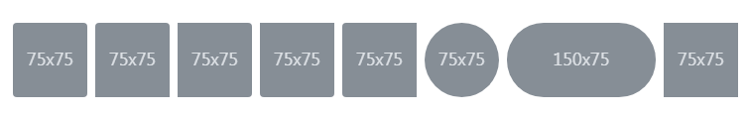

<img src="..." alt="..." class="rounded">

<img src="..." alt="..." class="rounded-top">

<img src="..." alt="..." class="rounded-right">

<img src="..." alt="..." class="rounded-bottom">

<img src="..." alt="..." class="rounded-left">

<img src="..." alt="..." class="rounded-circle">

<img src="..." alt="..." class="rounded-pill">

<img src="..." alt="..." class="rounded-0">

**Sombras**

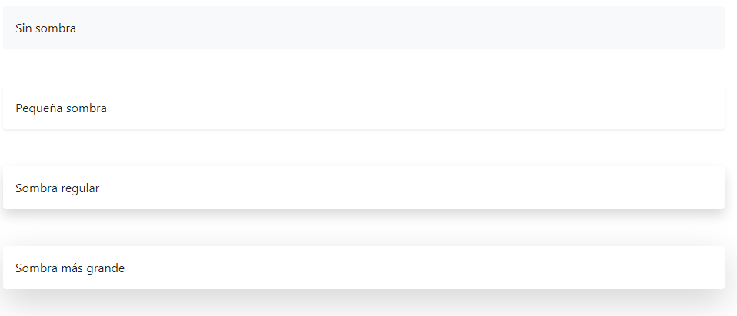

<div class="shadow-none p-3 mb-5 bg-light rounded">No shadow</div>

<div class="shadow-sm p-3 mb-5 bg-white rounded">Small shadow</div>

<div class="shadow p-3 mb-5 bg-white rounded">Regular shadow</div>

<div class="shadow-lg p-3 mb-5 bg-white rounded">Larger shadow</div>